SOFT8026 - Data-driven Microservices
Assignment 1 Form

Instructions
Please complete the following form and include in the zip file you submit. Include screenshots / images in the appendices below the form.

Which dataset (e.g. from Kaggle) did you use (provide a download link)?

Link - Video Game Sales | Kaggle
The dataset is provided with code (In the client directory)

Briefly describe the data in the file and some of the columns you chose to analyse:

The dataset consists of a list of game sales greater than 100k copies. It contains game sales in different regions such as Europe, USA etc along with the game description such as name, year released, platform on which the game was released, game genre and game publishers. I have used these columns for analysis – Game name, Game genre, sales in North America, Europe, Japan and rest of the world.

Discussion of Architecture
Put a diagram of your architecture opposite (e.g. paste an image); indicate the microservices, integration endpoints, messages being sent, etc. | 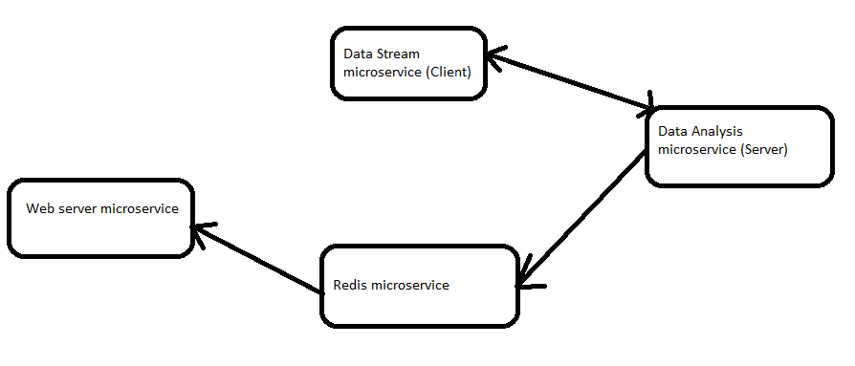  The assignment follows the above architecture.  The Data stream or client microservice is responsible to read lines from the dataset and is responsible to provide the data analysis microservice with 2 entries and uses sleep function so that data isn’t passed immediately. The data analysis microservice is responsible to analyse the 2 entries in real time and send results to web server microservice through redis. The web server then logs the result in a tabular format on a web page.
Why did you opt for the microservices you did? You could address topics from the lectures, e.g. bounded contexts, independent pipelines, etc. | I would briefly like to describe these 2 topics that would give an idea on why I choose the architecture:  Isolation – The subcomponent services are independent of each other. Only the client is dependent on the server to get the response.  Independent Pipelines – Pipelines for each microservice are completely independent to one other. In short, if they are updated the pipelines could run concurrently with each other.
Checklist of requirements completed | Delete as appropriate
Do you have a Dockerfile per microservice that you have created? | YES  Every microservice has their respective docker file
Do you have your Dockerfiles and other microservice files (python scripts, requirements.txt, etc) in separate folders? | YES  All the required by a microservice are in their respective folders.
Do you have a functioning Docker Compose file? | YES  The dockercompose files points to microservice and is responsible to start the microservices with a single “docker-compose up” command.
Are you streaming data, simulating real-time throughout? | YES
Do you have 4 pieces of analytics calculated, including a window-on-data (e.g. rolling 3-minute window)? | YES  The analysis microservice is responsible to analyse the following –  Total number of copies sold in all regions for 2 entries, Average number of copies sold in all regions for 2 entries, Top selling game genre from 2 entries and Top selling game from 2 entries.  For rolling 3-minute-window, I calculate the average number of copies sold in all regions in the previous 3 minutes (3-minute-rolling metric).
Are you displaying live analytics on a web page? | YES  The above-mentioned pieces are calculated in realtime.
Any other comments, e.g. anything you want to highlight that could otherwise be missed by the marker? | The proto directory is not a microservice, it only contains proto files.

Appendix – Screenshot(s) of your application running (e.g. Log output as it starts up, any log output as it runs, any web pages, etc.)

Results before rolling 3 minute rolling metric –

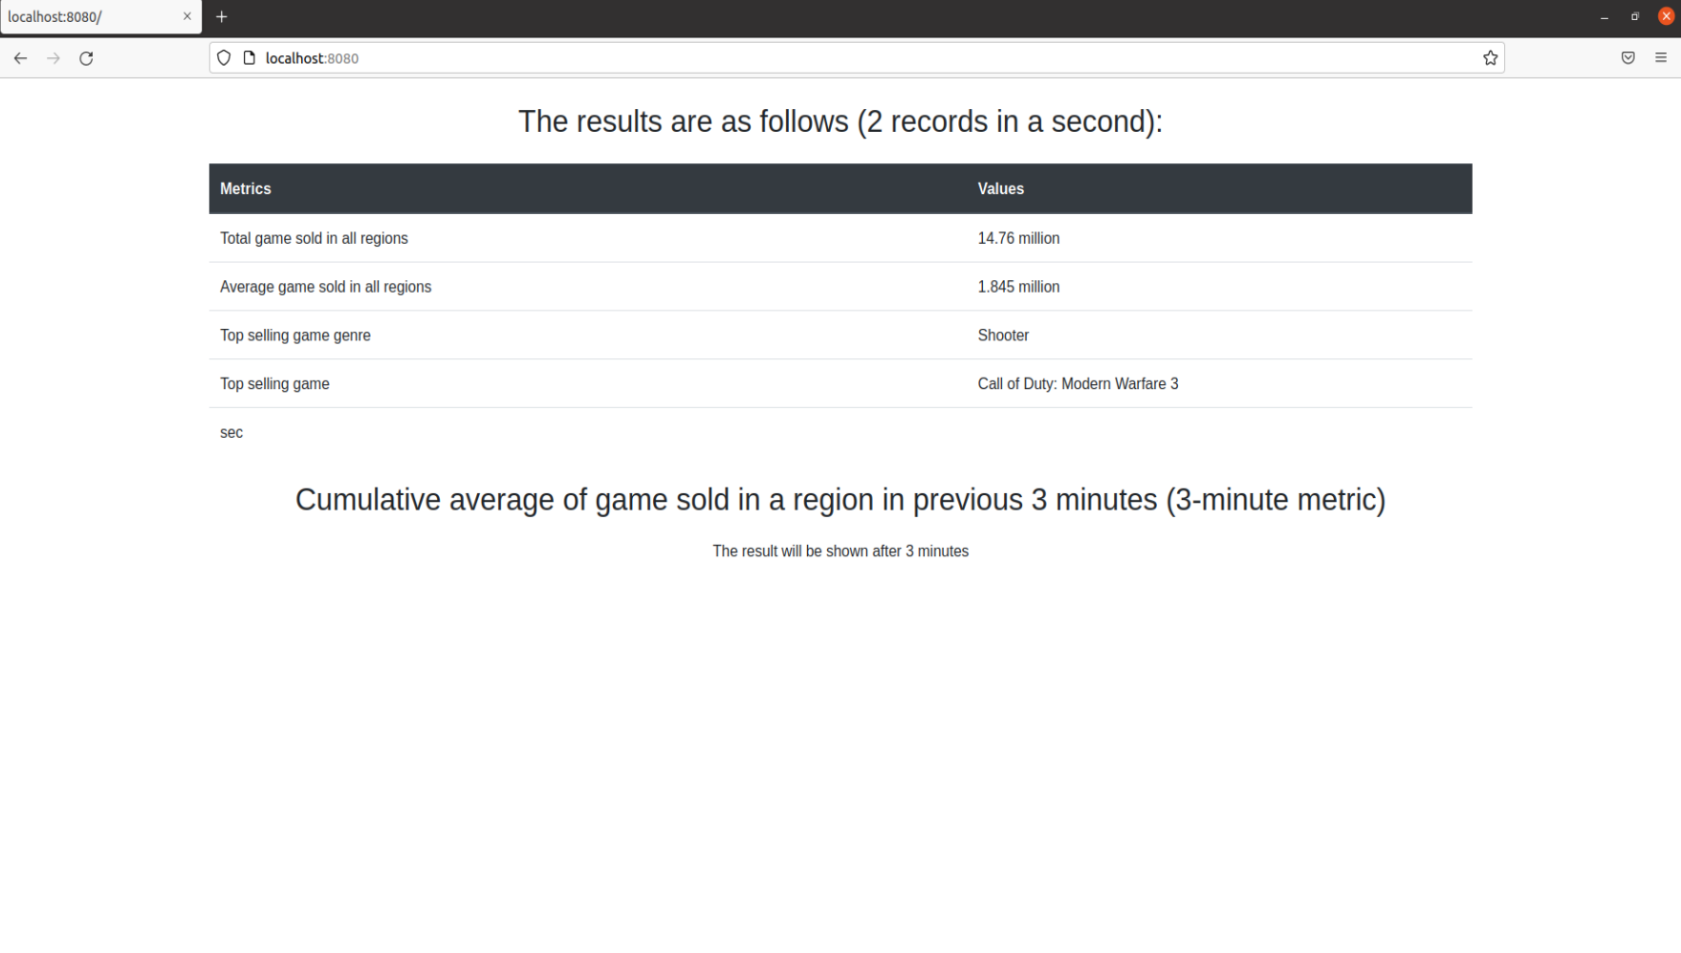

Results after 3 minute rolling metric –

